**Cricketer’s Stats**

Team Member 1

Atif Baloch

### **Table of Contents**

**Table of Contents**

**Mission Statement**

**Database**

**Features**

**Trello Link**

**Wireframe**

**Schedule**

**Final Notes**

### 

### 

### **Mission Statement**

**This App lets user write stats of a Cricketer. Some of these stats can be created, edited, deleted or just received for information only using CRUD Operation for One Day International and Test Cricket matches.**

### 

### Database

This is where your team writes out how your database will look like. List out each table, the columns (include the dataTypes), and the database associations your project will have on the server-side.

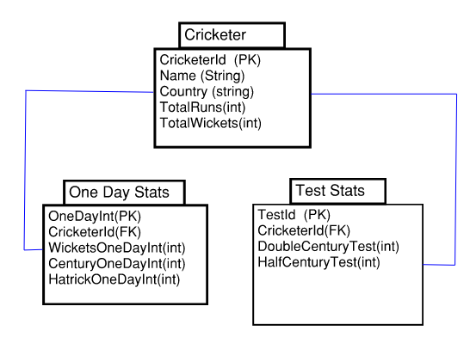

Optional:

Additional Tables:

**Used Bluebeam to create wireframe**

### Features

Features are instances or examples of different pieces of functionality. This is where your team lists out the features you are planning on implementing. Consider the different steps and logic those features require to do the expected job. This could include fetching data from a 3rd party API or simply looping over data from your server. Differentiate between your version 1.0 or MVP (minimal viable product) and version 2.0 or stretch goals.

### 

|  |  |
| --- | --- |
| **Version 1.0 / MVP** | **Version 2.0 / Stretch Goals** |
| * **This App allows users to keep track of Stats for individual Cricket player for One Day International Match** * **This App allows users to keep track of Stats for individual Cricket player for Test International Match** | * **To add more pulldown features so user can comprehensively add more information to individual player of their choice as they progress through their one day or Test match Cricket Career** * **Add Player Stats for T-20 International Matches** |
| **Future Goals** | **Version 3.0:**  **This app can be extended to add Team Stats** |

### 

### Trello Link

Once you have your features listed out, start writing out the tickets that each feature includes on your team’s Trello Board. Paste the link here.

**Trello Link for Cricket Stats Project: https://trello.com/b/kSfZLhAB/cricket-stats**

### Schedule

This project is the equivalent of one sprint in the agile methodology. In this section, write out a schedule spanning over the next couple of weeks. This should include deployment, time set aside to tackle especially challenging features, testing, etc. Consider whether your team will be working over the weekend(s). The table below is a guideline. It is not necessary to specify each day’s work/logic. Feel free to estimate your time.

|  |  |  |  |  |  |  |
| --- | --- | --- | --- | --- | --- | --- |
| **Day 1** | **Day 2** | **Day 3** | **Day 4** | **Day 5** | **Day 6** | **Day 7** |
| Scaffold out 3 N-Tier Tables/Set Up Github | Scaffold out 3 N-Tier Tables | Work on Data Class | Work on Data Class | Work on Models | Work on Models | Write out the logic in Services |
| **Day 8** | **Day 9** | **Day 10** | **Day 11** | **Day 12** | **Day 13** | **Day 14** |
| Write out the logic in Services | Work on Controller | Work on Controller | Start working on Views | Start working on Views | Testing Out the Program (User Inputs/Outputs) | Clean up the code and start to make Front End modifications |
| **Day 15** | **Day 16** | **Day 17** | **Day 18** |  |  |  |
| Start Working on Stretch Goals | Start Working on Stretch Goals | Start Working on Stretch Goals | Submit Project |  |  |  |

Sources to be used for the project:

* <https://getbootstrap.com/>
* <https://www.w3schools.com/>
* <https://elevenfifty.org/>
* https://stackoverflow.com/

### Final Notes

Great job with planning! You are now set to start coding. Planning a project is incredibly beneficial to the success of your team and your project. Here are some resources to help you with your planning.

* [How to plan a web application](https://selftaughtcoders.com/plan-web-application/)
* [Step By Step: Planning a web application](https://medium.com/@ericwindmill/step-by-step-planning-a-web-application-ddaa010a8353)